**Web Technologies**

**MSIS 517L**

**Assignment 7 - Adit Kulkarni**

**Screenshots –**

The first time a user logs in to the websie, a pop-up will be displayed asking for user name.

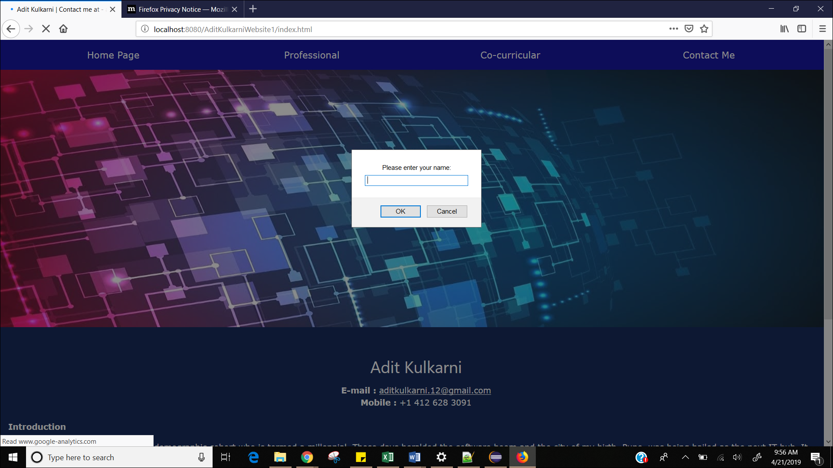

The cookies will be stored by username, the name entered.

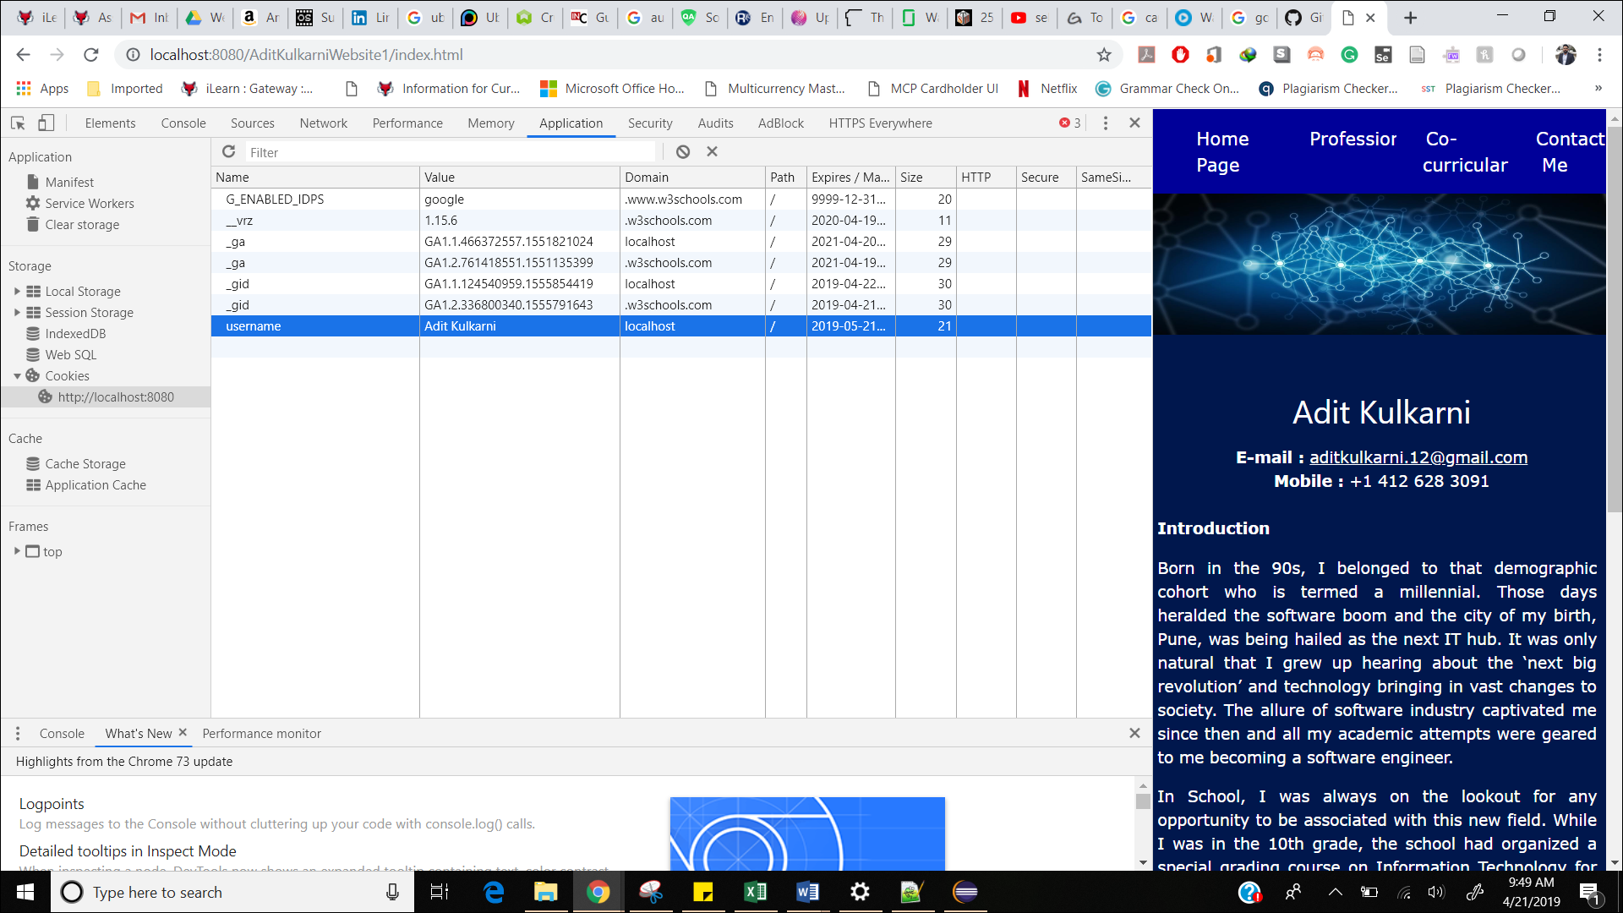

If the same user returns again, then he won’t be prompted with the dialog box asking for his/her name, the dialog box will pop-up only for the first time.

